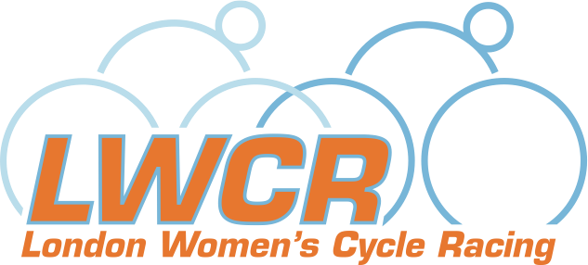
Sponsored by



NEW WOMEN’S CYCLE RACING LEAGUE FOR 2010
Grassroots league encourages women of all levels into racing

LONDON, 8th February 2010: London Women’s Cycle Racing (LWCR), a group of women cyclists from London and the South East, has formed a new league to attract more women into racing. This year’s League is sponsored by lookmumnohands.com, and consists of a series of 12 events from March to August, including circuit races, road races, time trials, and crits.

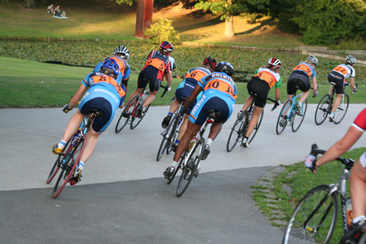
Photo 1 - courtesy LondonCycleSport.com - women's racing at Crystal Palace

The grassroots group behind the League set up this new initiative to build on women’s local level racing, and address key issues such as low participation in events and difficulty for clubs to appeal to women.

“The London Women’s Cycle Racing League gives women riders of all levels an opportunity to develop their racing skills and participate in healthy local competition. Most importantly, it’s about women having fun on their bikes,” explains Maria David of Dulwich Paragon and LWCR group co-ordinator.

Riders are awarded league points in an individual competition, as well as scoring points for their club. A prize presentation event, in collaboration with sponsors look mum no hands!, will be a night to look forward to. Not only will the top riders and clubs receive awards, but the League will also reward riders who have shown significant improvement, commitment, or given worthy performances.

Maria continues, “Riders right up to elite category get the opportunity to compete against each other and test themselves in a variety of different events. We welcome novice racers, and we’re here to answer their questions about how to get involved. With points scored by every participating league rider at each event, taking part really does count.”

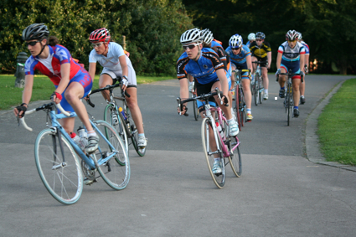
Photo 2 - courtesy LondonCycleSport.com - women's racing at Crystal Palace

The League has already been met with positive reactions from the cycling community. According to Team Orbea-For Goodness Shakes rider Janet Birkmyre, “London Women's Cycle Racing League is a fantastic opportunity for women to try racing in a friendly and supportive atmosphere, and for others simply to get some more race miles in.” While for London Dynamo’s Claire Beaumont, “This is a great idea and helps tie together races around the region, meet other like-minded people, and more importantly, have fun! I’m really looking forward to it.”

Ten cycling clubs have already pledged their support, and the league is accepting further affiliations from local clubs. “By joining the League, clubs are encouraging women’s racing in a practical way. They can also use our logo to publicize their commitment, which should help them attract more women members,” explains Liz Rice of London Phoenix and LWCR group co-ordinator.

Event organisers welcome the London Women’s Cycle Racing League and see it as a chance to increase the numbers of women participating in their events. “We welcome any initiative that brings more women into racing,” says Surrey League Chief Executive, Keith Butler. “Road racing isn’t that gentle a sport, but our remit is to get women on board gently by putting on races for new racers. We are very happy to see a league which does that.”

For more information and to affiliate to the London Women’s Cycle Racing League, or to enquire about additional prize sponsorship opportunities, please visit our website: www.londonwomenscycleracing.com

About London Women’s Cycle Racing
London Women’s Cycle Racing is a team of enthusiastic riders and supporters of women’s riding and racing.

Clubs who have already pledged their support:
- Addiscombe CC
- Charlotteville CC
- Dulwich Paragon
- East London Velo
- Kingston Wheelers
- London Dynamo
- London Phoenix
- Pearsons
- Rollapaluza
- Twickenham CC
Contacts:
Maria David: 07976422394, mod56uk@yahoo.co.uk
Liz Rice: 07801261145, liz@lizrice.com
www.londonwomenscycleracing.com

Photos should be credited to LondonCycleSport.com. High-resolution versions are available on request.

About look mum no hands!
Our sponsors look mum no hands! will be launching soon!
Contacts:
Matt Harper: 07884025219, matthew@lookmumnohands.com
www.lookmumnohands.com

